

**UNIVERSITY OF PETROLEUM & ENERGY STUDIES**

**Dehradun**

**CONTINOUS INTEGRATION**

**AND**

**CONTINOUS DELIVERY**

**Docker commands**

**Name: Harshil BHardwaj**

**Course: B. TECH CSE DevOps (2018-22)**

**Roll no.: R171218045**

**Sapid: 500068580**

**Experiment-13**

**Step-1:** open your web browser and search katacoda

Or visit the provided link: -https://www.katacoda.com/courses/docker/deploying-first-container

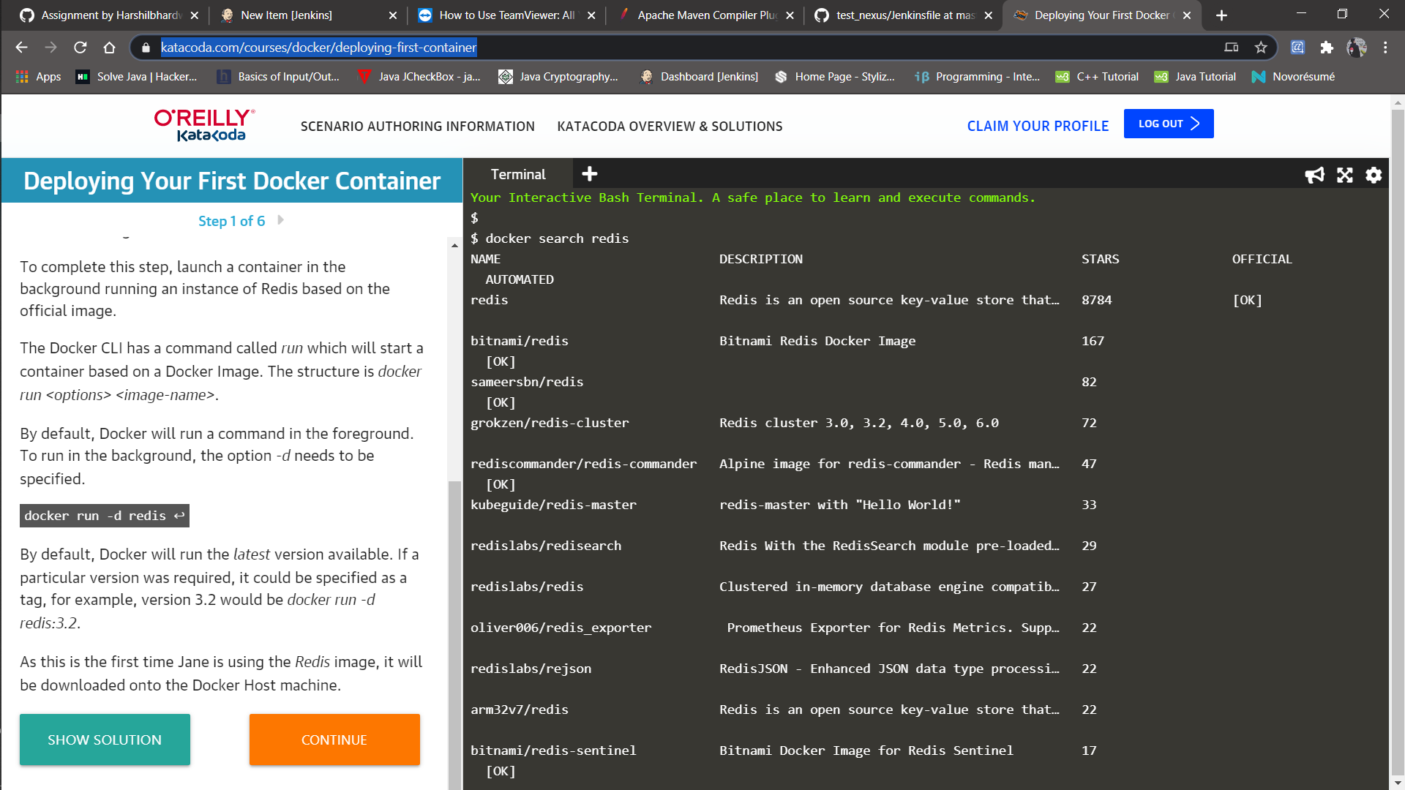

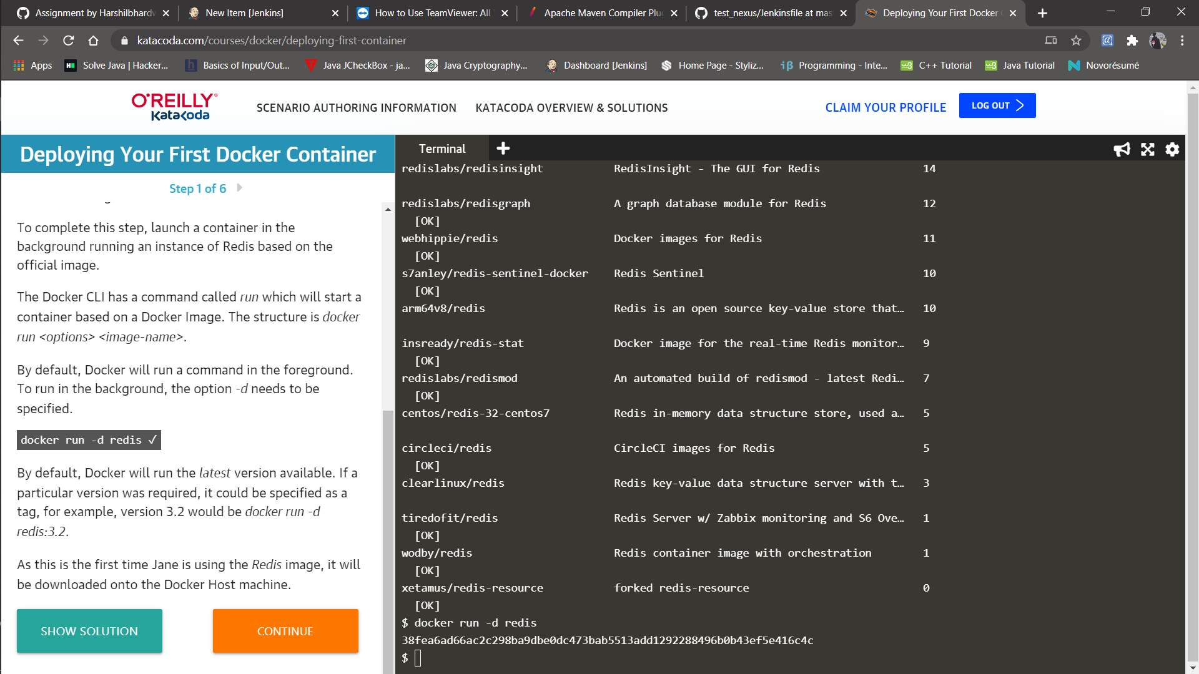

**Step-2:** Move to the Step two of your katacoda practice of deploying your first container.

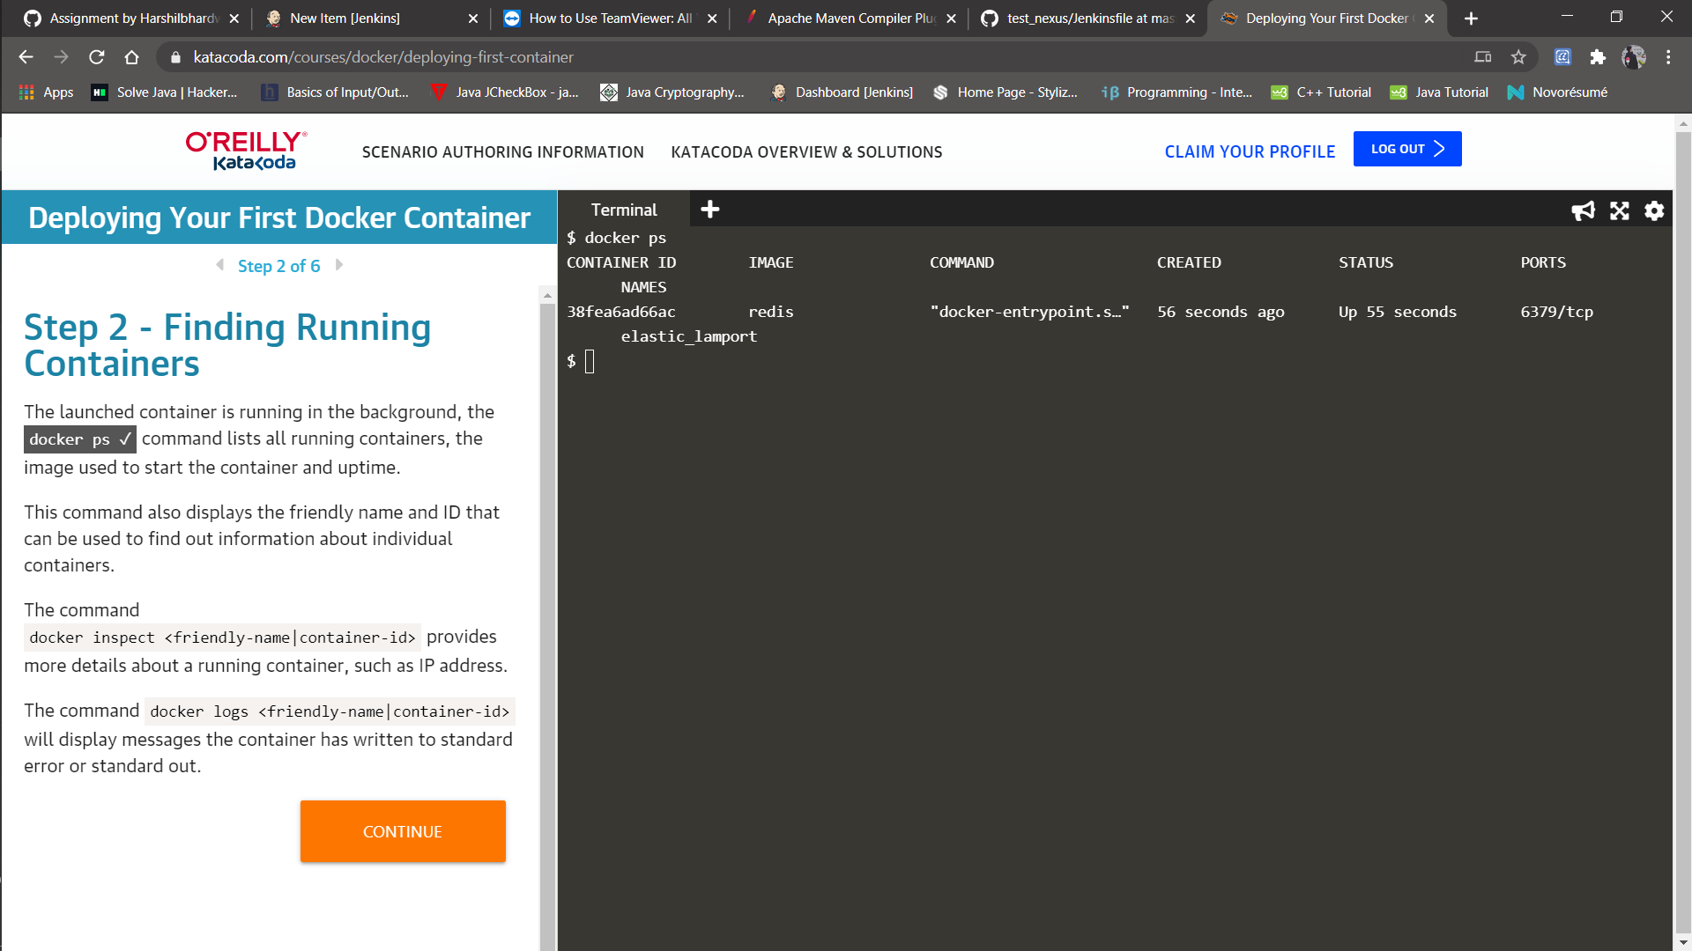

**Step-3:**

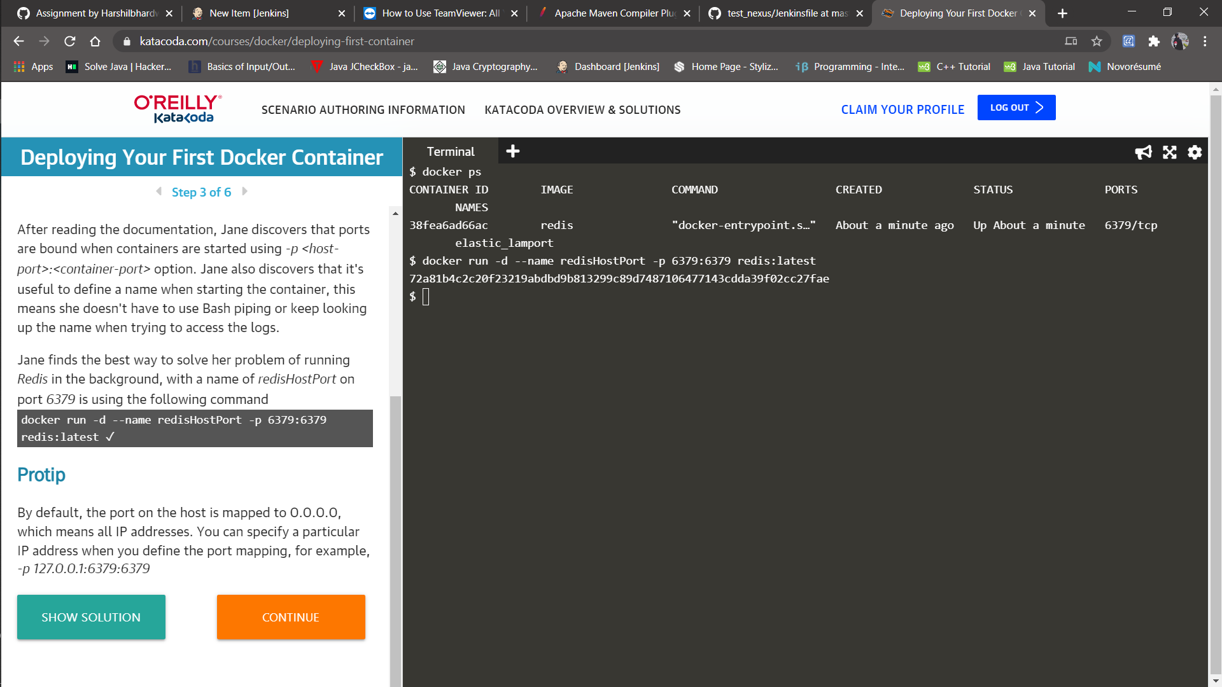

**Step-4:**

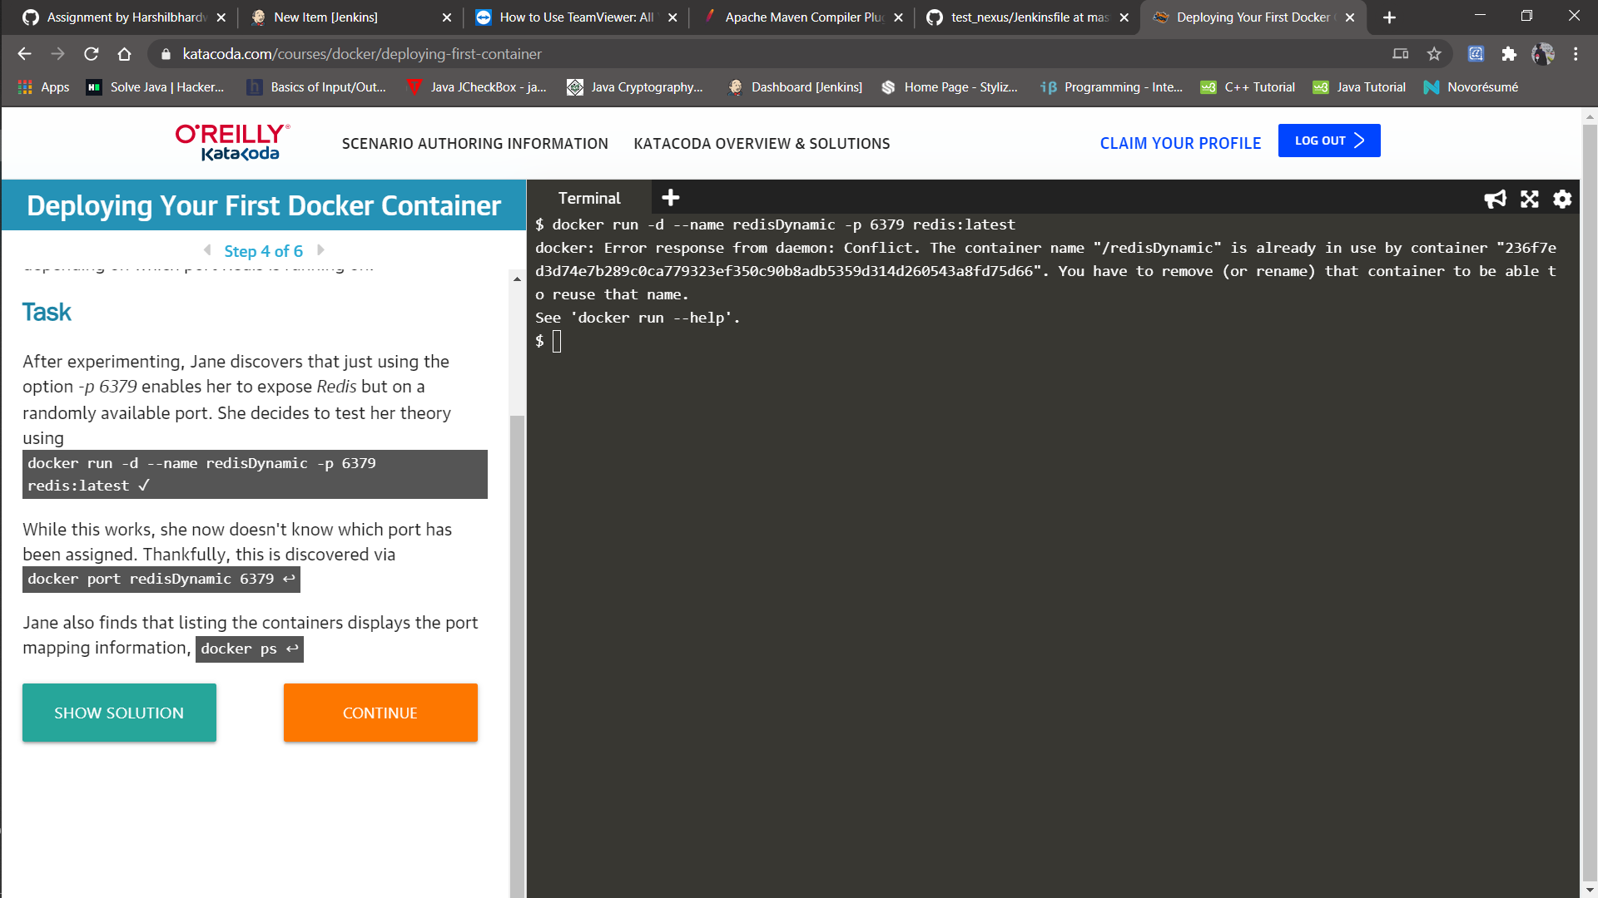 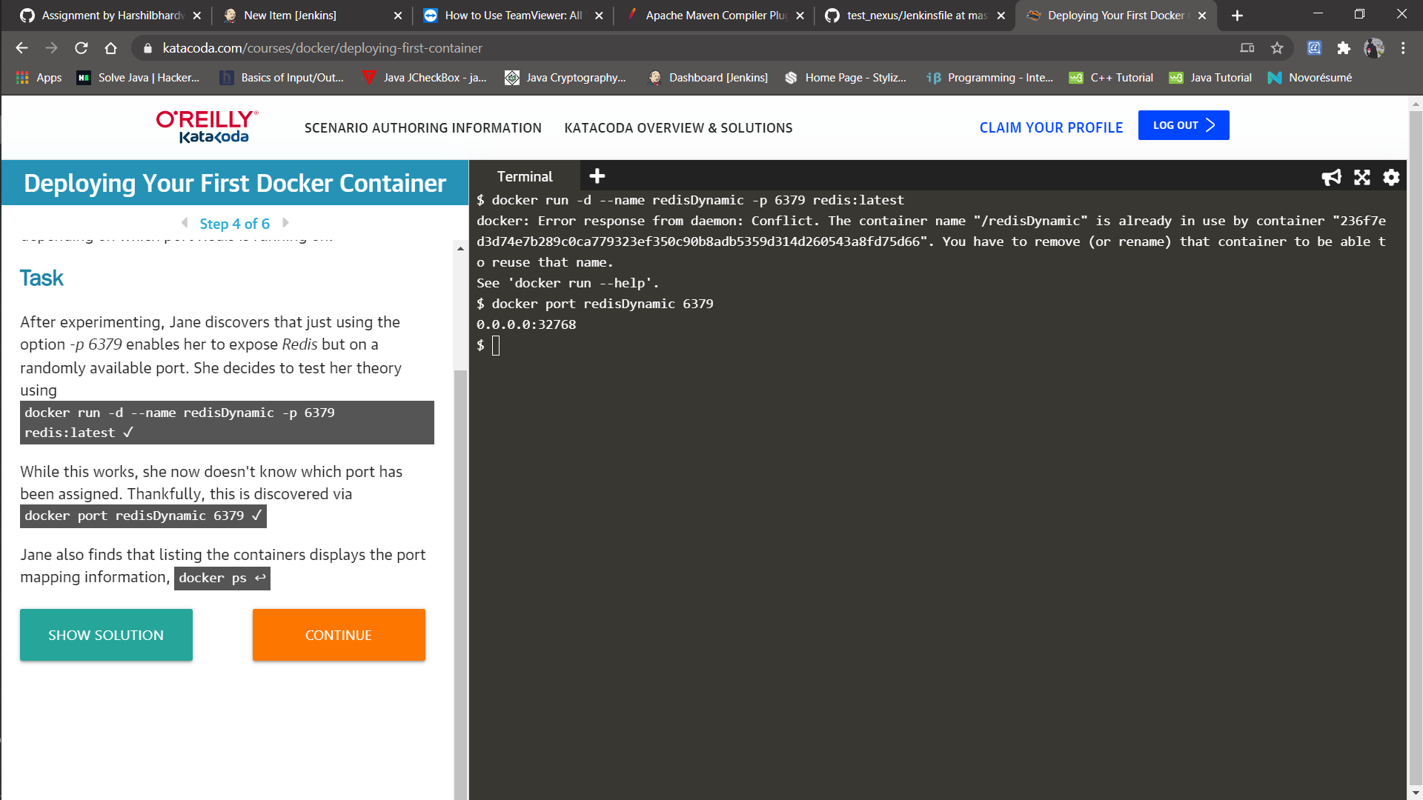 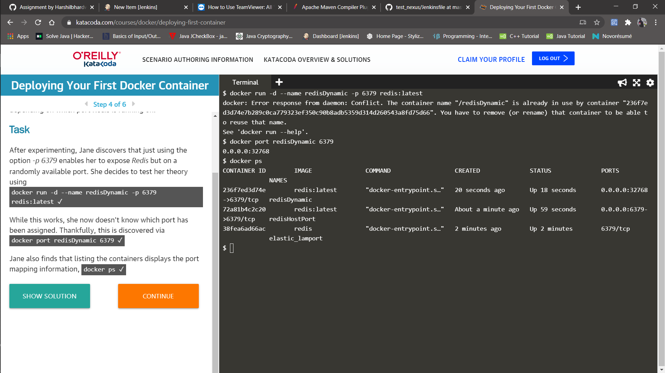

**Step-5:**

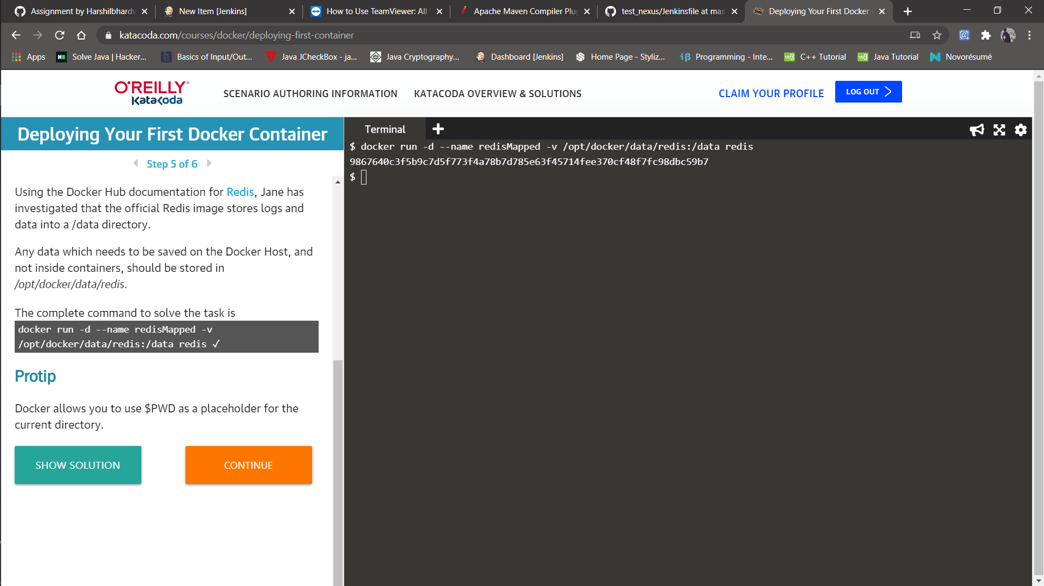

**Step-6:**

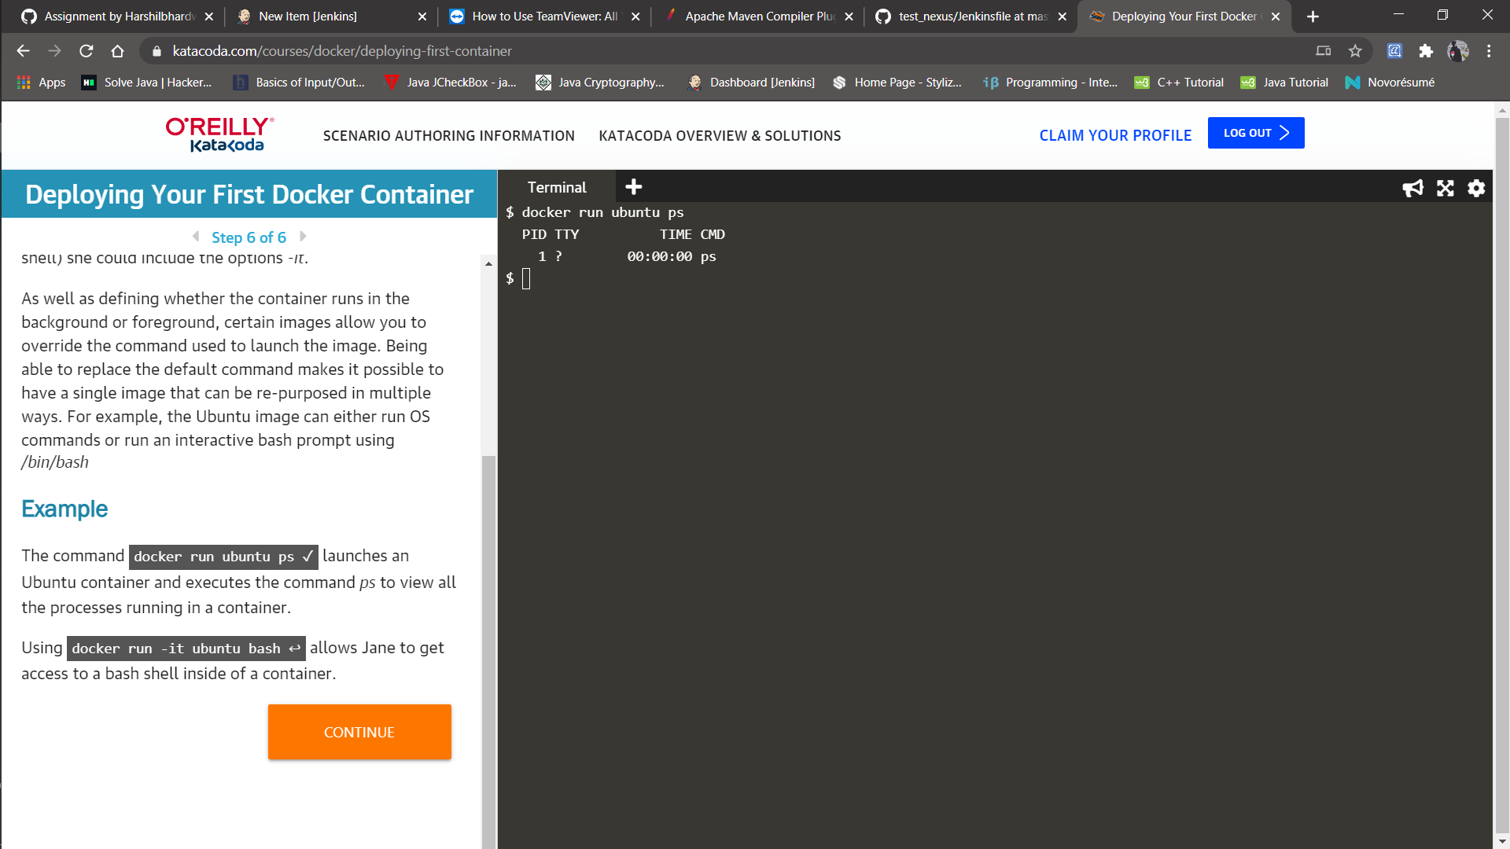 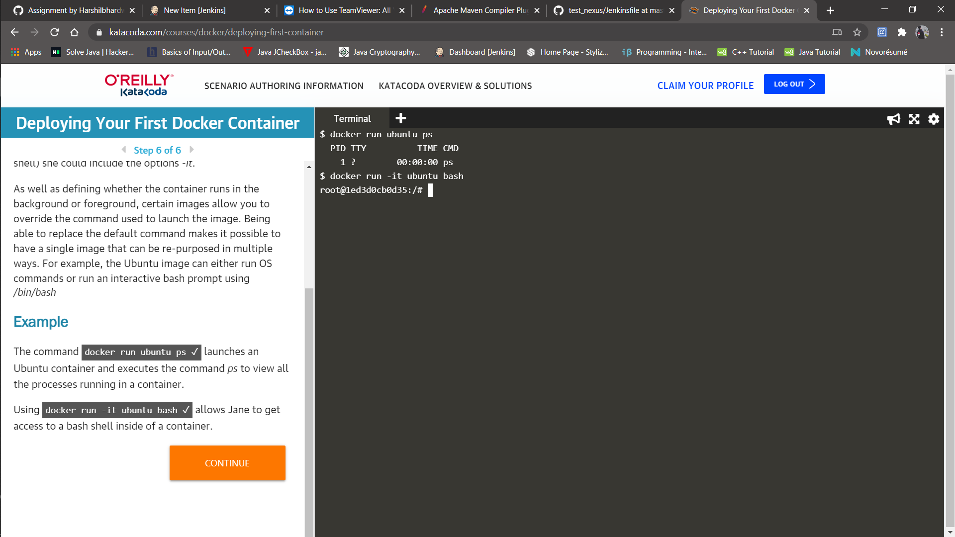

**Congratulations you deployed your first docker container successfully !!.**